Article written by Skye Nott. Published on 2006-04-02
MG Experience Library – Service:Electrical and Instruments Section
The contents of this article are © Copyrighted and published under the following terms:
Copyright © the author and published by permission or under fair use.

The variety of speedometers fitted to the MGB is a common source of confusion, especially in relation to the fairly common practise of swapping O/D and fully synchronized transmissions into B's that didn't originally have them. This will consequently cause the speedometer and odometer to read too fast, or too slow.

"Revs" in the table below referrs to the turns-per-mile the speedo expects from the speedometer cable. The TPM of your speedo should be printed somewhere on the face, along with a serial number.

Any variation in tire size from original specifications will of course also have an effect on the accuracy of your speedometer. See the discussion on tires and tire sizes in the Service section of the Library for more information on this topic.

The NAMGBR also has a cross reference table from car numbers to speedometer serial numbers.

KMR reports that if you have a setup that doesn't correlate to any existing speedometer type, Nisonger can put a new faceplate on your speedometer, and recalibrate that way. Check the Directory section of this website for contact information on companies that provide Smiths/Jaeger instrument servicing.

Tooth count (transmission):

Overdrive - 21
Normal - 27
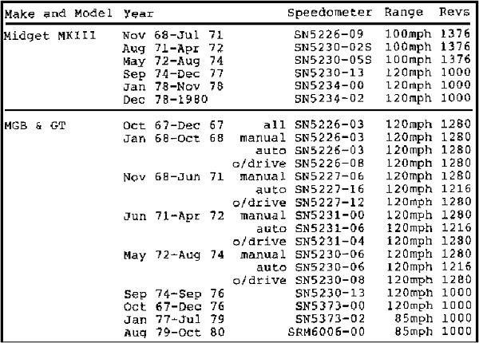
Thanks to Bruce Mills for scanning and submitting in this chart - it's a lot more complete than the chart I was building

